throw new Exception('Money transfer failed: ' . VarDumper::dumpAsString($sender->getErrors()) . VarDumper::dumpAsString($recipient->getErrors())

);

}

} catch ( Exception $e ) {

$transaction->rollBack(); throw $e;

}

}

}

4. Run test/success and you should get the output shown in the following screenshot:

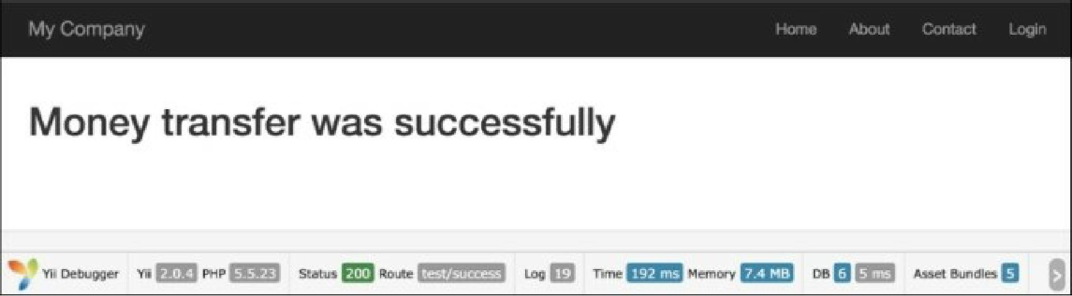

5. In this case, the transaction mechanism will not update the recipient and sender balance if some error occurred.

6. Run test/error and you should get the output shown in the following screenshot:

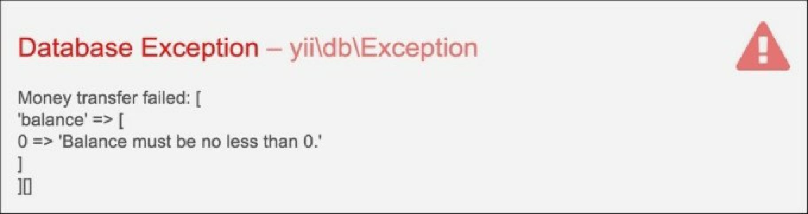

As you will remember, we added a rule to the Account model, so our account balance can be only positive. The transaction will roll back in this case and it prevents a situation where money is withdrawn from a sender’s account but not deposited to the recipient’s account.

See also